Jesus Nolazco

Chapter 8

**Page 197 Object constructor**

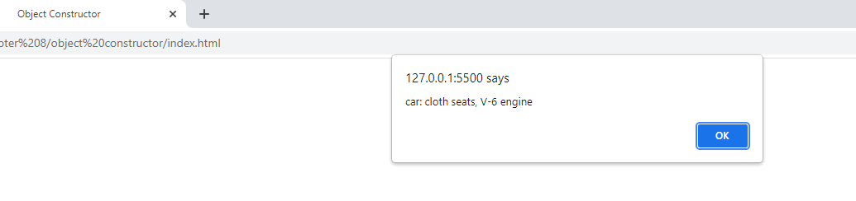

<!DOCTYPE html>

<html>

<head>

    <title>Object Constructor</title>

</head>

<body>

    <script src="obconjs.js"></script>

</body>

</html>

let car = new Object();

car.seats = "cloth";

car.engine = "V-6";

car.show_features = function() {

    window.alert("car: " + car.seats + " seats, " + car.engine + " engine");

};

car.show_features();

**Page 197 Named function as method**

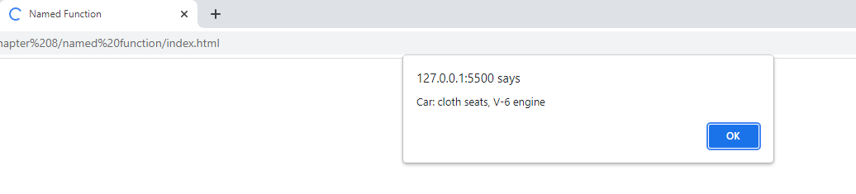

<!DOCTYPE html>

<html>

<head>

    <title>Named Function</title>

</head>

<body>

    <script src="namefuncjs.js"></script>

</body>

</html>

let car = new Object();

car.seats = "cloth";

car.engine = "V-6";

function my_alert() {

    window.alert("Car: " + car.seats + " seats, " + car.engine + " engine");

}

car.show_features = my_alert;

car.show_features();

**Page 198 Object literal**

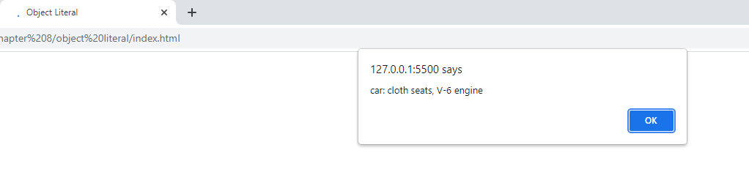

<!DOCTYPE html>

<html>

<head>

    <title>Object Literal</title>

</head>

<body>

    <script src="objlitjs.js"></script>

</body>

</html>

let car = {

    seats: "cloth",

    engine: "V-6",

    show_features: function() {

        window.alert("car: " + car.seats + " seats, " + car.engine + " engine");

    }

};

car.show_features();

**Page 198 Dot notation**

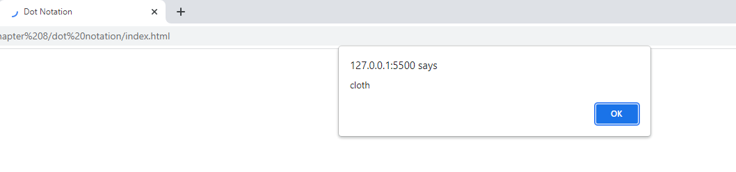

<!DOCTYPE html>

<html>

<head>

    <title>Dot Notation</title>

</head>

<body>

    <script src="dotjs.js"></script>

</body>

</html>

let car = {

    seats: "cloth",

    engine: "V-6"

};

window.alert(car.seats);

**Page 199 Bracket notation**

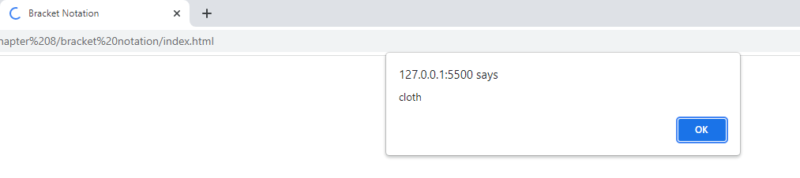

<!DOCTYPE html>

<html>

<head>

    <title>Bracket Notation</title>

</head>

<body>

    <script src="bracketjs.js"></script>

</body>

</html>

let car = {

    seats: "cloth",

    engine: "V-6"

};

window.alert(car["seats"]);

**Page 199 Concatenation and variables**

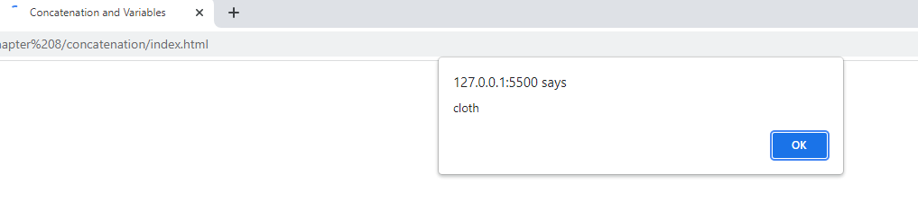

<!DOCTYPE html>

<html>

<head>

    <title>Concatenation and Variables</title>

</head>

<body>

    <script src="convarjs.js"></script>

</body>

</html>

let car = {

    seats: "cloth",

    engine: "V-6"

};

let s = "seats";

let start = "sea";

window.alert(car["seats"]);

window.alert(car["sea" + "ts"]);

window.alert(car[s]);

window.alert(car[start + "ts"]);

**Page 199 No variable values**

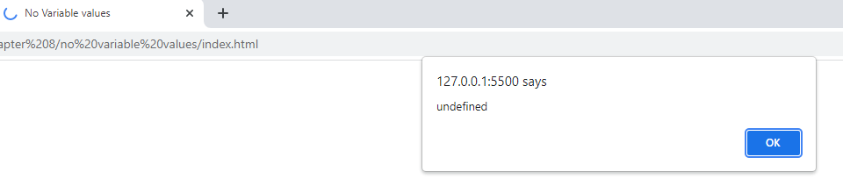

<!DOCTYPE html>

<html>

<head>

    <title>No Variable values</title>

</head>

<body>

    <script src="novarjs.js"></script>

</body>

</html>

let car = {

    seats: "cloth",

    engine: "V-6"

};

let s = "seats";

function show_seat_type(sts) {

    window.alert(car.sts);

}

show_seat_type(s);

**Page 200 Bracket notation with property name**

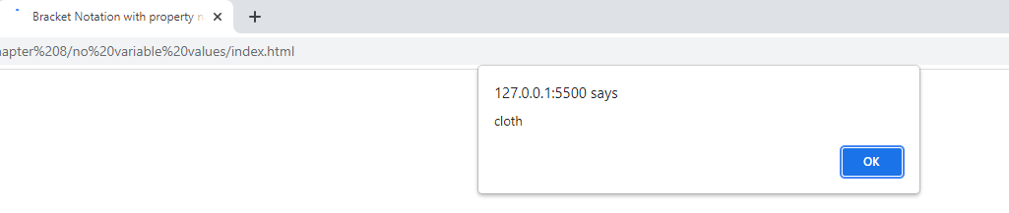

<!DOCTYPE html>

<html>

<head>

    <title>Bracket Notation with property name</title>

</head>

<body>

    <script src="novarjs.js"></script>

</body>

</html>

let car = {

    seats: "cloth",

    engine: "V-6"

};

let s = "seats";

function show_seat_type(sts) {

    window.alert(car[sts]);

}

show_seat_type(s);

**Try This 8-1**

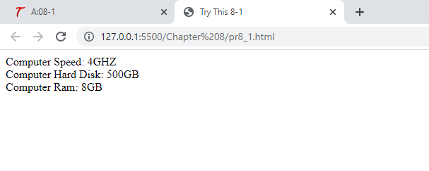

<!DOCTYPE html>

<html>

<head>

    <title>Try This 8-1</title>

</head>

<body>

    <script src="prjs8_1.js"></script>

</body>

</html>

let computer = {

    speed: "4GHZ",

    hd: "500GB",

    ram: "8GB"

};

document.write("Computer Speed: " + computer.speed + "<br>");

document.write("Computer Hard Disk: " + computer.hd + "<br>");

document.write("Computer Ram: " + computer.ram);

**Page 203 Instances**

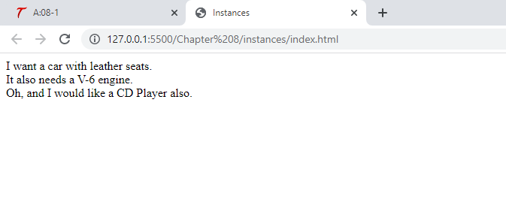

<!DOCTYPE html>

<html>

<head>

    <title>Instances</title>

</head>

<body>

    <script src="instancesjs.js"></script>

</body>

</html>

function Car(seats, engine, radio) {

    this.seats = seats;

    this.engine = engine;

    this.radio = radio;

}

let work_car = new Car("cloth", "V-6", "Tape Deck");

let fun_car = new Car("leather", "V-8", "CD Player");

document.write("I want a car with " + fun_car.seats + " seats.<br>");

document.write("It also needs a " + work_car.engine + " engine.<br>");

document.write("Oh, and I would like a " + fun_car.radio + " also.");

**Page 204 Property Values**

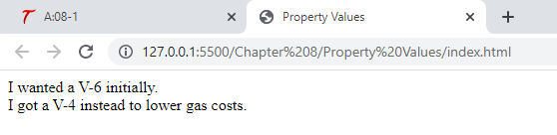

<!DOCTYPE html>

<html>

<head>

    <title>Property Values</title>

</head>

<body>

    <script src="propvaljs.js"></script>

</body>

</html>

function Car(seats, engine, radio) {

    this.seats = seats;

    this.engine = engine;

    this.radio = radio;

}

let work_car = new Car("cloth", "V-6", "Tape Deck");

let fun_car = new Car("leather", "V-8", "CD Player");

let original_work_car_engine = work_car.engine;

work_car.engine = "V-4";

let new_work_car_engine = work_car.engine;

document.write("I wanted a " + original_work_car_engine + " initially.<br>");

document.write("I got a " + new_work_car_engine + " instead to lower gas costs.");

**Page 205 Adding methods**

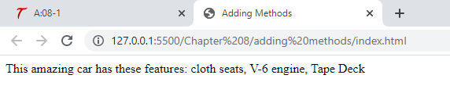

<!DOCTYPE html>

<html>

<head>

    <title>Adding Methods</title>

</head>

<script src="methodjs.js"></script>

</html>

function Car(seats, engine, radio) {

    this.seats = seats;

    this.engine = engine;

    this.radio = radio;

    this.describe = function() {

        document.write("This amazing car has these features: ");

        document.write(this.seats + " seats, " + this.engine + " engine, ");

        document.write(this.radio);

    };

}

let work_car = new Car("cloth", "V-6", "Tape Deck");

work_car.describe();

**Page 206 Move function outside**

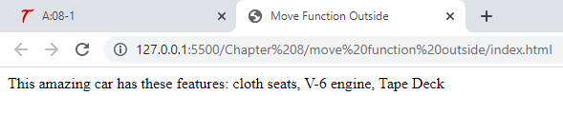

<!DOCTYPE html>

<html>

<head>

    <title>Move Function Outside</title>

</head>

<body>

    <script src="movefuncjs.js"></script>

</body>

</html>

function Car(seats, engine, radio) {

    this.seats = seats;

    this.engine = engine;

    this.radio = radio;

    this.describe = describe_car;

}

function describe_car() {

    document.write("This amazing car has these features: ");

    document.write(this.seats + " seats, " + this.engine + " engine, ");

    document.write(this.radio);

}

let work_car = new Car("cloth", "V-6", "Tape Deck");

work_car.describe();

**Page 207 Working with prototypes**

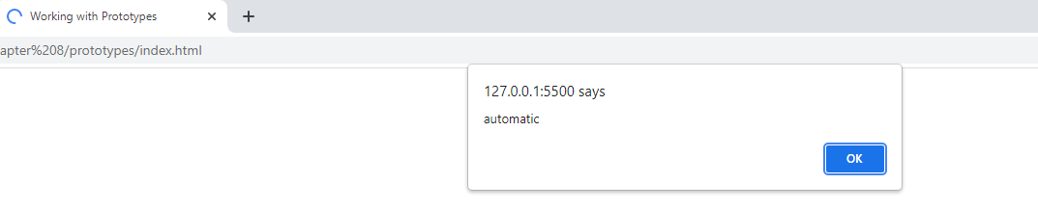

<!DOCTYPE html>

<html>

<head>

    <title>Working with Prototypes</title>

</head>

<body>

    <script src="protojs.js"></script>

</body>

</html>

function Car(seats, engine, radio) {

    this.seats = seats;

    this.engine = engine;

    this.radio = radio;

}

Car.prototype.locks = "automatic";

let work_car = new Car("cloth", "V-6", "Tape Deck");

let family_car = new Car("cloth", "V-4", "CD Changer");

window.alert(work_car.locks);

window.alert(family_car.locks);

**Page 208 Adding same name property**

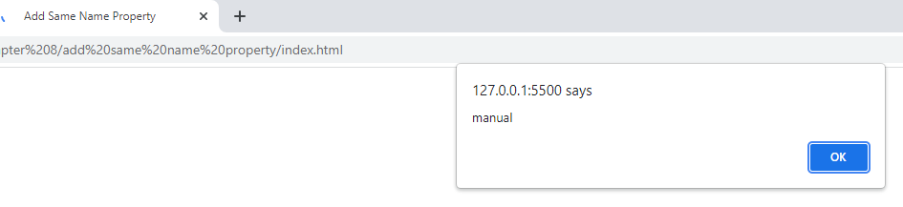

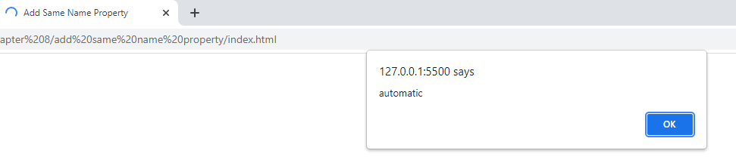

<!DOCTYPE html>

<html>

<head>

    <title>Add Same Name Property</title>

</head>

<body>

    <script src="samenamejs.js"></script>

</body>

</html>

function Car(seats, engine, radio) {

    this.seats = seats;

    this.engine = engine;

    this.radio = radio;

}

Car.prototype.locks = "automatic";

let work_car = new Car("cloth", "V-6", "Tape Deck");

let family_car = new Car("cloth", "V-4", "CD Changer");

work_car.locks = "manual";

window.alert(work_car.locks);

window.alert(family_car.locks);

**Page 208 hasOwnProperty()**

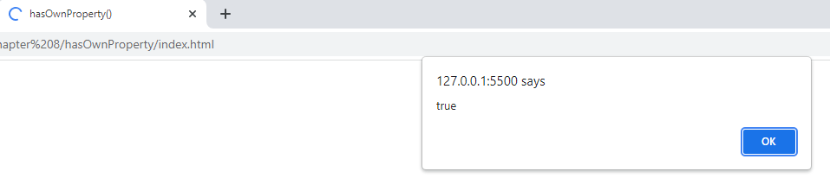

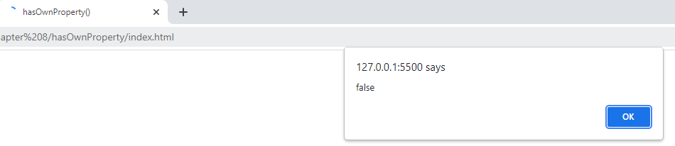

<!DOCTYPE html>

<html>

<head>

    <title>hasOwnProperty()</title>

</head>

<body>

    <script src="hasownjs.js"></script>

</body>

</html>

function Car(seats, engine, radio) {

    this.seats = seats;

    this.engine = engine;

    this.radio = radio;

}

Car.prototype.locks = "automatic";

let work_car = new Car("cloth", "V-6", "Tape Deck");

let family_car = new Car("cloth", "V-4", "CD Changer");

work_car.locks = "manual";

window.alert(work_car.hasOwnProperty("locks"));

window.alert(family_car.hasOwnProperty("locks"));

**Page 209 Prototypes for methods**

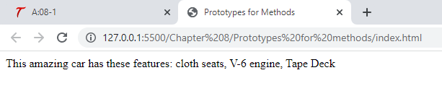

<!DOCTYPE html>

<html>

<head>

    <title>Prototypes for Methods</title>

</head>

<body>

    <script src="protojs.js"></script>

</body>

</html>

function Car(seats, engine, radio) {

    this.seats = seats;

    this.engine = engine;

    this.radio = radio;

}

Car.prototype.describe = function() {

    document.write("This amazing car has these features: ");

    document.write(this.seats + " seats, " + this.engine + " engine, ");

    document.write(this.radio);

};

let work_car = new Car("cloth", "V-6", "Tape Deck");

work_car.describe();

**Page 209 Class keyword**

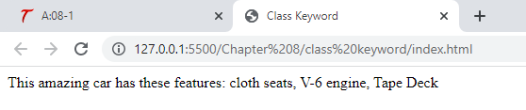

<!DOCTYPE html>

<html>

<head>

    <title>Class Keyword</title>

</head>

<body>

    <script src="classjs.js"></script>

</body>

</html>

class Car {

    constructor(seats, engine, radio) {

        this.seats = seats;

        this.engine = engine;

        this.radio = radio;

    }

    describe() {

        document.write("This amazing car has these features: ");

        document.write(this.seats + " seats, " + this.engine + " engine, ");

        document.write(this.radio);

    }

}

let work_car = new Car("cloth", "V-6", "Tape Deck");

work_car.describe();

**Page 211 for-in loop**

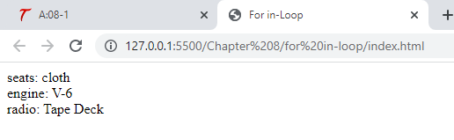

<!DOCTYPE html>

<html>

<head>

    <title>For in-Loop</title>

</head>

<body>

    <script src="inloopjs.js"></script>

</body>

</html>

function Car(seats, engine, radio) {

    this.seats = seats;

    this.engine = engine;

    this.radio = radio;

}

let work_car = new Car("cloth", "V-6", "Tape Deck");

for (let prop_name in work_car) {

    document.write(prop_name + ": " + work_car[prop_name] + "<br>");

}

**Page 211 for-in / hasOwnProperty()**

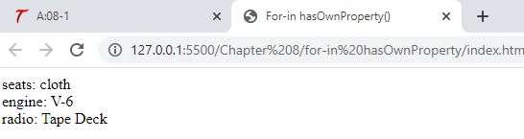

<!DOCTYPE html>

<html>

<head>

    <title>For-in hasOwnProperty()</title>

</head>

<body>

    <script src="inhasownjs.js"></script>

</body>

</html>

function Car(seats, engine, radio) {

    this.seats = seats;

    this.engine = engine;

    this.radio = radio;

}

let work_car = new Car("cloth", "V-6", "Tape Deck");

for (let prop_name in work_car) {

    if (work_car.hasOwnProperty(prop_name)) {

        document.write(prop_name + ": " + work_car[prop_name] + "<br>");

    }

}

**Page 212 Try This 8-2**

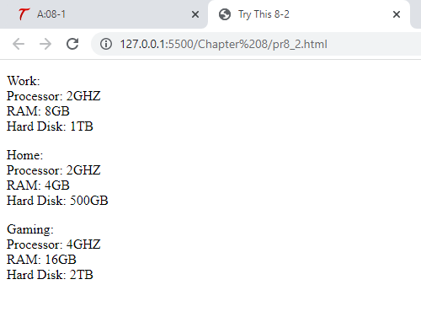

<!DOCTYPE html>

<html>

<head>

    <title>Try This 8-2</title>

</head>

<body>

    <script src="prjs8_2.js"></script>

</body>

</html>

function Computer(type, processor, ram, hd) {

    this.type = type;

    this.processor = processor;

    this.ram = ram;

    this.hd = hd;

}

Computer.prototype.describe = function() {

    document.write("<p>" + this.type + ":<br>");

    document.write("Processor: " + this.processor + "<br>");

    document.write("RAM: " + this.ram + "<br>");

    document.write("Hard Disk: " + this.hd + "</p>");

};

let work_computer = new Computer("Work", "2GHZ", "8GB", "1TB");

let home_computer = new Computer("Home", "2GHZ", "4GB", "500GB");

let gaming_computer = new Computer("Gaming", "4GHZ", "16GB", "2TB");

work_computer.describe();

home_computer.describe();

gaming_computer.describe();